GHOULIES AND GHOSTIES  IDENTIFY THE FULL NAMES OF THESE HORRIBLE CHARACTERS.  INSERT TWO NAMES WHERE REQUIRED, SOME HAVE BEEN FILLED IN FOR YOU. |  | 2 FREDDIE KREUGER  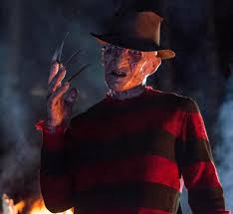
2. JACK SKELLINGTON  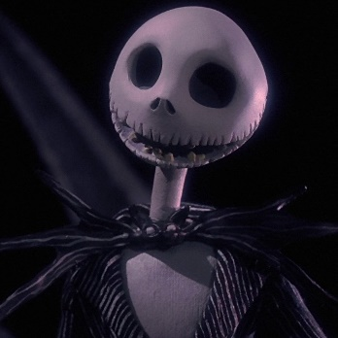 | 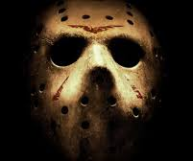  3. JASON VORHEES | 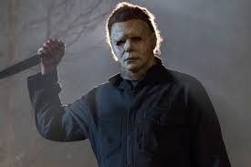  4. MICHAEL MYERS
5. DR. FREANKENSTEIN  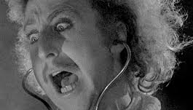 | 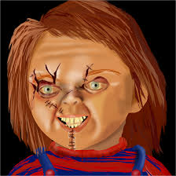  6. CHUCKIE | 7. THE BRIDE OF FRANKENSTEIN
8. RENFIELD  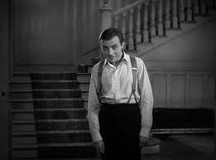 | 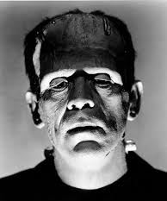  9. FRANKENSTEIN’S MONSTER | 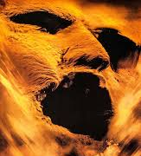  10 THE MUMMY

