1-5 Original Spitting Image  6-10 New Spitting Image (2020) |  | 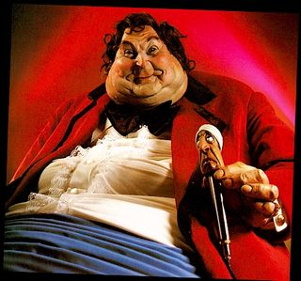  1 Bernard Manning
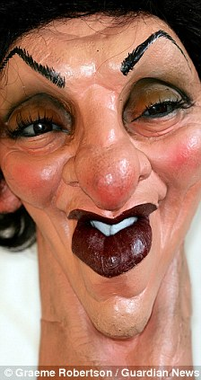  2 Edwina Currie | 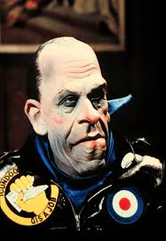  3 Norman Tebbit | 4 Salman Rushdie  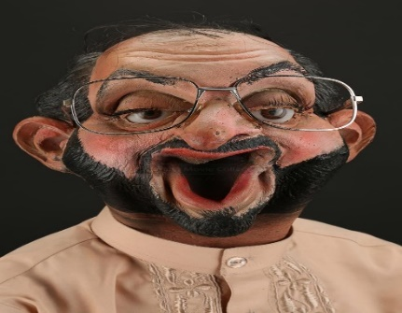
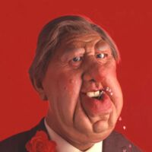  5 Roy Hattersley | 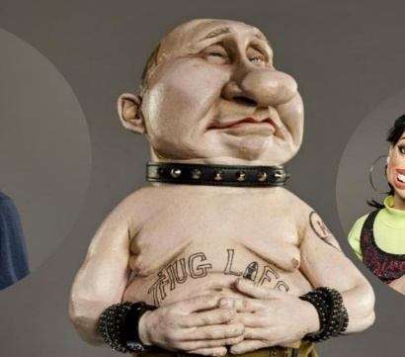  6 Vladimir Putin | 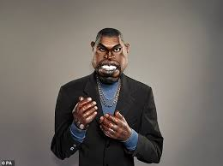  7 Kanye West
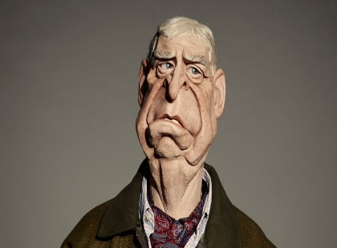  8 Prince Andrtew | 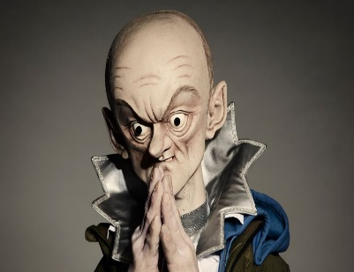  9 Dominic Cummings | 10 Mark Zuckerberg  