Q29 TELEVISION
N.B. in Q 14 just answer who were Bodie and Doyle
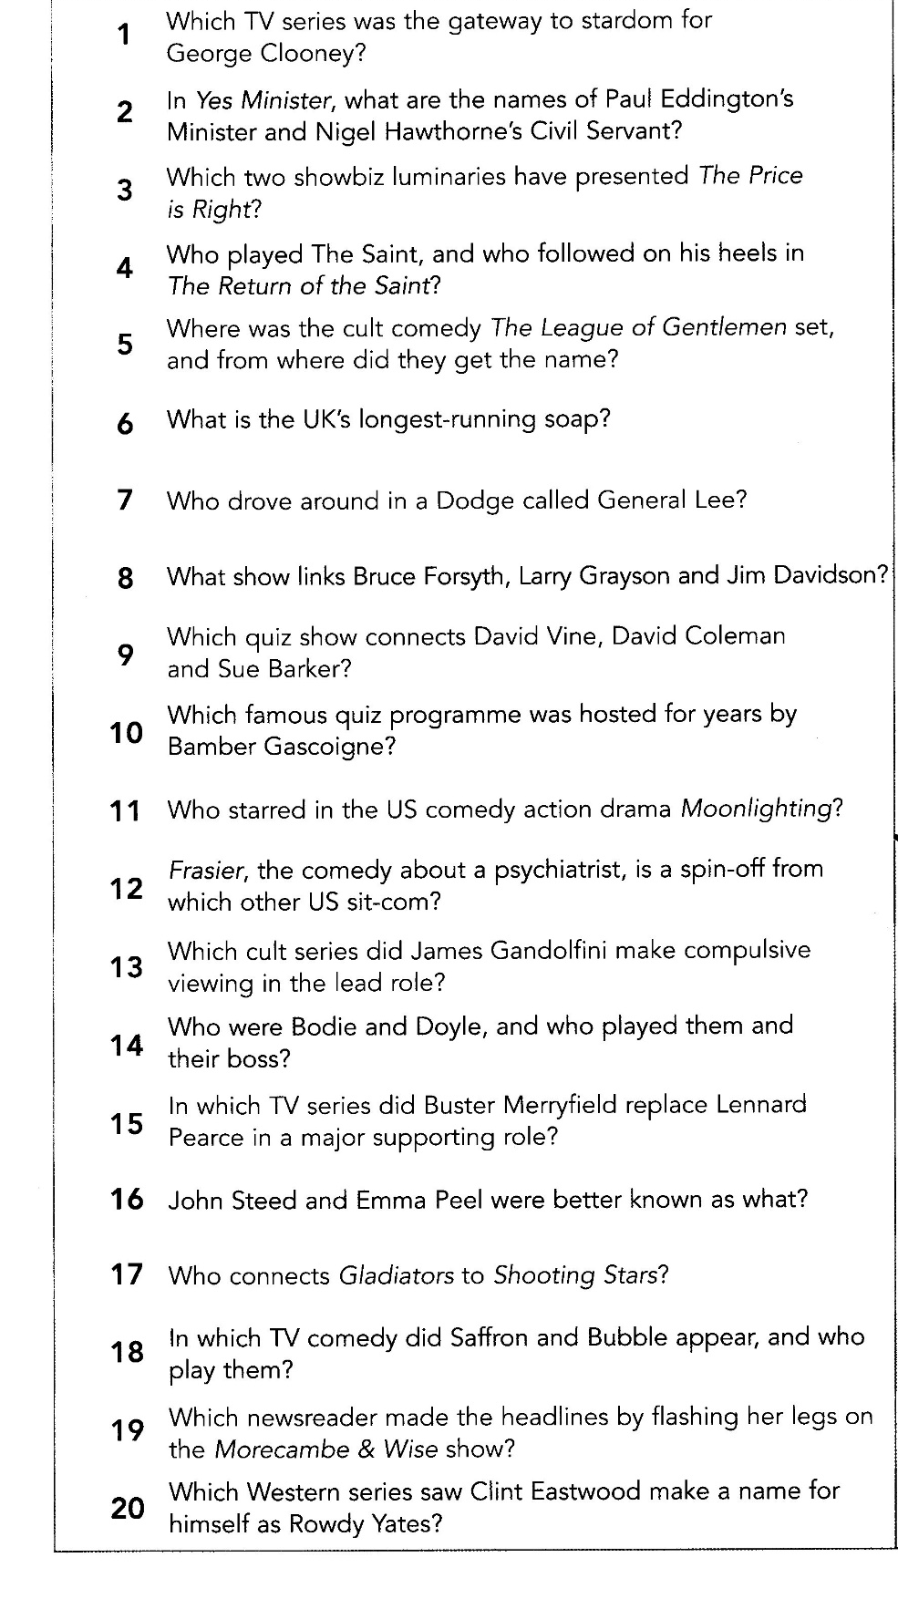
In Q 18 Just name the TV show and not the actors

Q 37 MOUNTAIN HIGH#
N.B. in Q 12 answer any 2 out of 3 for the point
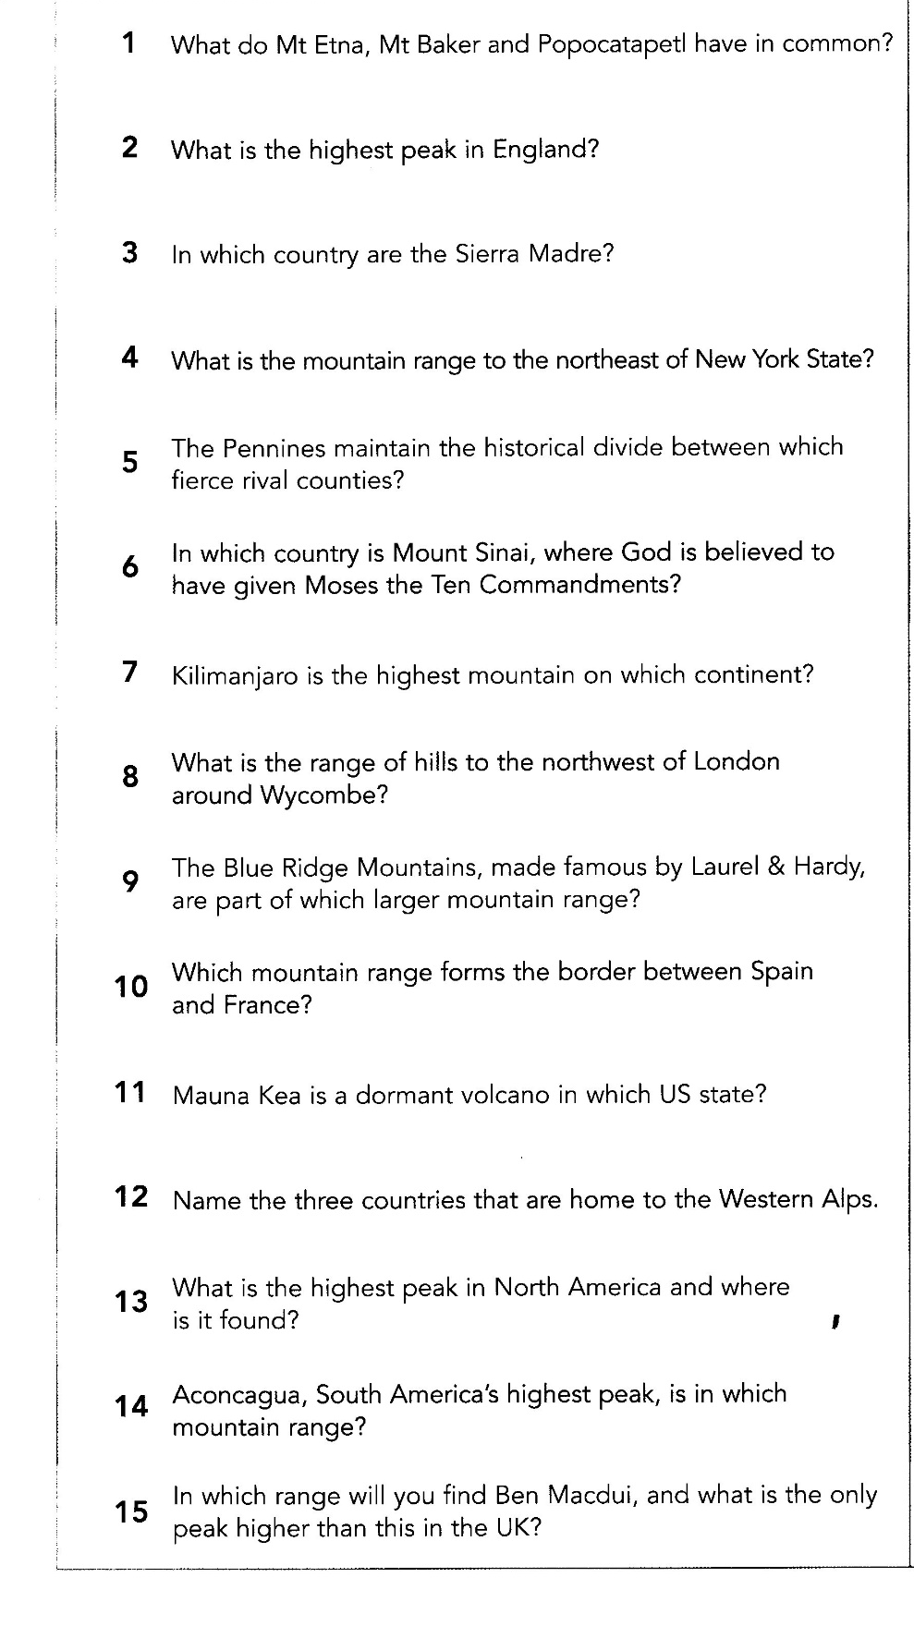

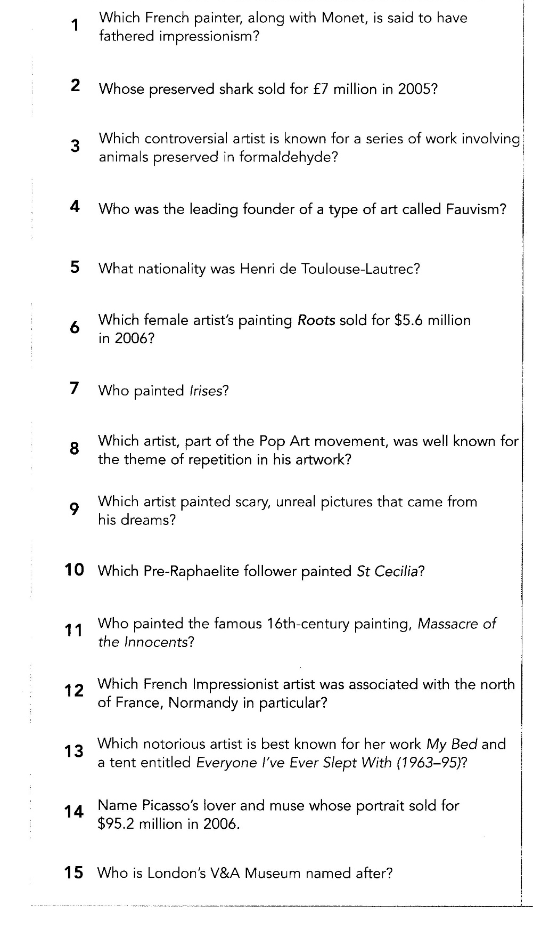
Q38 ART & ARTISTS

