10 NEEDLEWORK PARAPHERNALIA  QUESTIONS |  | 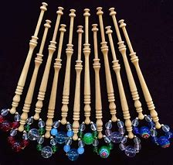  1 LACE MAKING BOBBINS
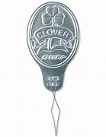  2 NEEDLE THREADER | 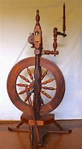  3 SPINNING WHEEL | 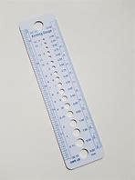  4 KNITTING NEEDLE GAUGE
5 TATTING SHUTTLE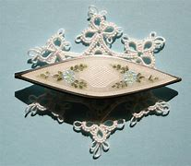 | 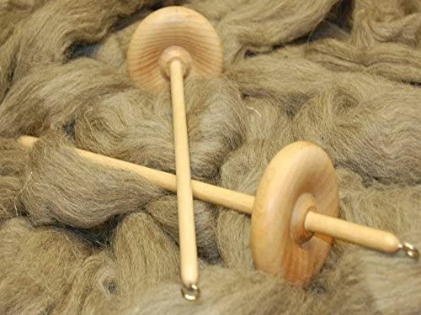  6 DROP SPINDLES | 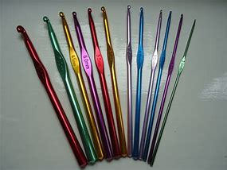  7 CROCHET HOOKS
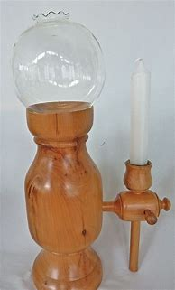  8 LACEMAKER’S LAMP | 9 SEWING MACHINE BOBBIN CASE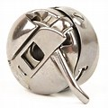 | 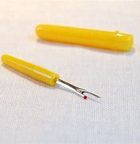  10 STICH/SEAM RIPPER

