FAMOUS PEOPLE WHO  DIED IN 2020 |  | 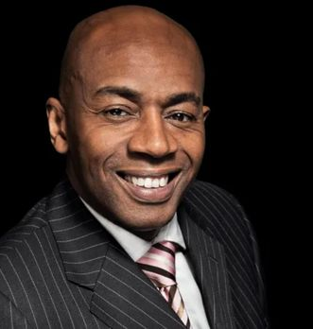  1 TONY MORRIS (GRANADA REPORTS)
2 JACKIE STALLONE | 3 GERARD HOULIER | 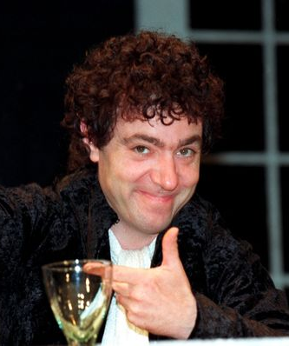  4 JOHN SESSIONS
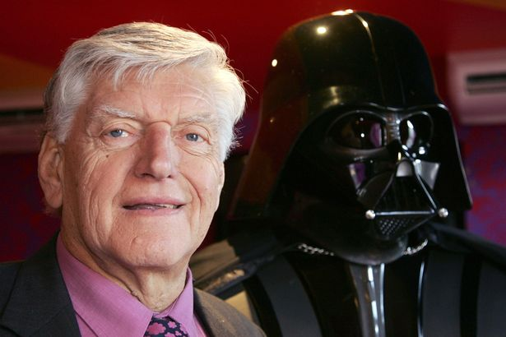  5 DAVID PROWSE | 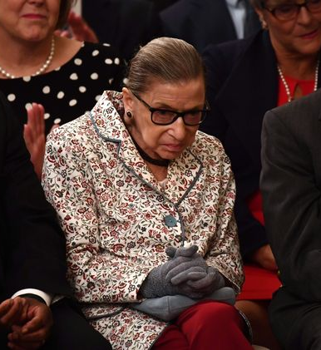  6 RUTH (BADER) GINSBURG | 7 DIEGO MARADONNA
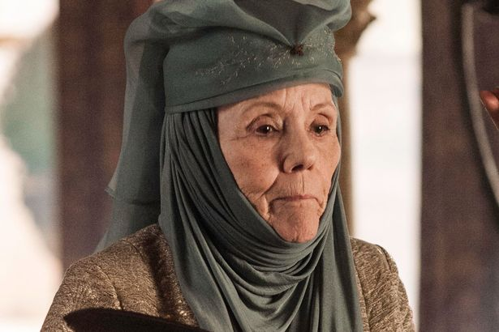  8 DIANA RIGG | 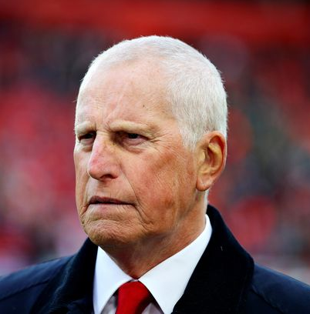  9 RAY CLEMENCE | 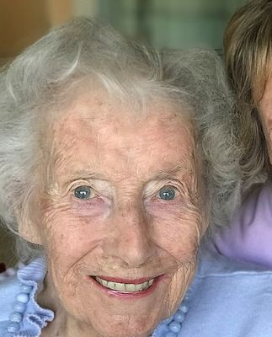  10 VERA LYNN

