FAMILY CONNECTIONS |  | 1 Kate and Pippa Middleton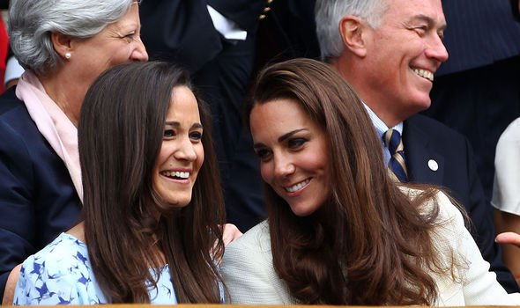
2 Alistair and Jonny Brownlee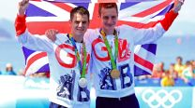 | 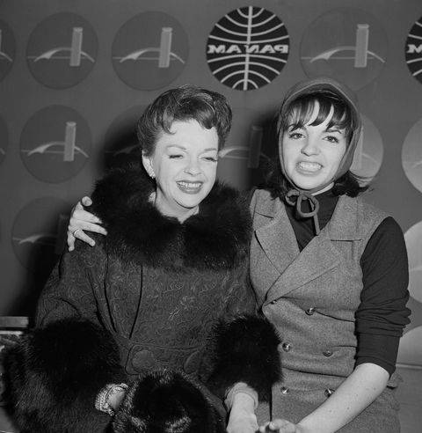  3 Judy Garland and Liza Minelli | 4 Noel and Liam Gallagher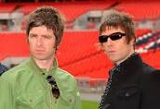
5 Neil and Steven Kinnock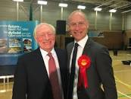 | 6 Tim and Jeremy Vine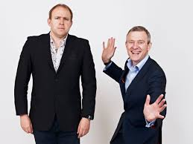 | 7 Serena and Venus Williams
8 Jackie and Bobby Charlton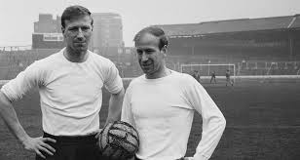 | 9 Bart and Homer Simpson | 10 Sophie Ellis Bextor and Janet Ellis